CURRICULUM VITÆ
Luca Angioletti

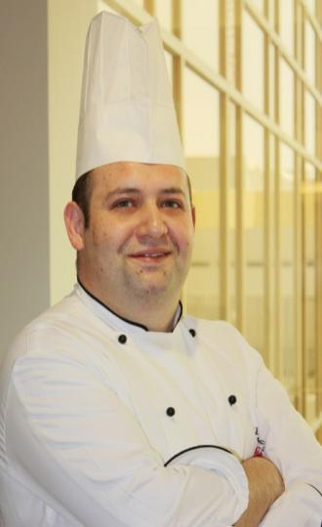

Skills
Accomplished chef with a strong combination of culinary experience and management skill coupled with award-winning menu preparation background. Extensive experience in food inventory, planning, procurement and management on both national and international levels.
Area of expertise includes:
International Culinary Experience , Customer Service , Staff Training/ Development, Cost Containment
Personnel Management and Motivation, Pre-opening, Quality Assurance, Award-Winning Menu Creation, Special Event Development , Highly Adaptable,Leadership/ Motivation

2017 November present Executive Sous Chef at Edsa Shangri-La Manila
Administrative, Menu Planning, Forecast Budgeting and Food Costing.
6 Restaurants and Bars
3 Ballrooms and 12 meeting rooms
630 Rooms

2010 September- 2017November Executive Sous Chef at “Radisson Blu Doha” www.radissonblu.com
Administrative, assisting the executive Chef in all Menu Planning, Forecast Budgeting and Food Costing.
Responsible for a team of 118 Chefs and 63 Stewards
Outdoor Catering up 1500 pax, 10 Conference Rooms
12 Restaurants and Bars
1 Ballroom and 7 meeting rooms
580 Rooms

2008 March– 2010 AugustChef de cuisine at “Al fresco restaurant”www.ihg.com CROWNE PLAZA ,Sheikh Zayed Road Dubai , Uae
Responsible for quality control creation and preparation of menus for HACCP standard, Food cost, give hands on during special function
Establish and maintain effective guest relations and engagement

2004 December– 2007 December Chef at “Relais Antico Borgo di Celle”www.relaisanticoborgodicelle.it , Cittá di Castello (Pg), Italy
Hotel restaurant specializing in wedding banquets for up to 300 people as well as providing seasonal “A la Carte” menus. Responsible for quality control creation and preparation banqueting, daily and seasonal menus.

2004 April- NovemberChef at “Hotel Abbazia dei Collemedio”www.bluhotels.it , Collazzone (Pg), Italy
Responsible for quality control creation and preparation of menus for groups as well as daily and seasonal menus.Hotel restaurant specializing in wedding banquets for up to 300 people
Only Open for Spring and Summer Time (7 months per year)

2003 November – 2004 MarchChef at “Le terre del verde”www.leterredelverde.it ,Gualdo Tadino (Pg), Italy
(Organic farm and pre opening)Responsible for quality control creation and preparation of menus for groups as well as daily and seasonal menus.Hotel restaurant specializing in wedding banquets for up to 400 people
Consultant just for the opening, set the standard and procedure

2002 May–2003October Chefde cuisine at “Met Restaurant”www.clubmet.it ,TerniItaly
(Opening) Mediterranean wine restaurant with A la Carte(fine dining) service with 40 person seating capacity, new concept restaurant on three level open from breakfast lunch and dinner finger food, business lunch wine bar and fine dining restaurant for 40 pax create new menus supervise and improve cost control.

Awards
After less than 6 months open, 74 points from GamberoRosso Restaurant Guide

2000December– 2001April Military service .

1999November - 2000NovemberChef de cuisine at “Desiderio”WiesbadenGermany
A la Carte restaurant (opening) with 40 person seating capacity, create new menus supervise and improve cost control. Implemented and consulted for traditional recipes and methods of cooking.
Awards
13 Points from “GautMillau” restaurant guide in 2000

ITALIAN FOOD FESTIVALS(promoting the Italian food and culture)
January 2006 Phoenix, Arizona.:One of two ItalianChef invited by the region of Umbria to give private cooking lessons and dinners.
March 2004 HoteldorfGrüner Baum(Austria) Italian Chef invited by the region of Umbria to give private cooking lessons and dinners.
November 2003 Saint Petersburg, Russia Italian Chef invited by the region of Umbria to give private cooking lessons and dinners.

