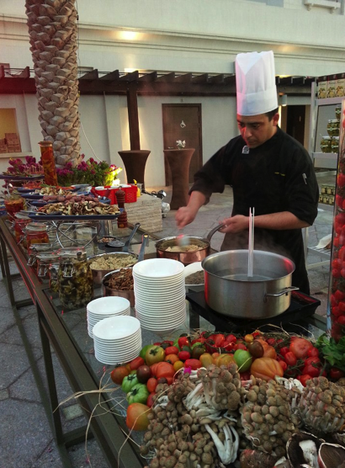

Francesco Lattarulo

Via Gregorovius 26

06127 Perugia

Italy

PERSONAL INFORMATION
E-mail: francelattarulo@gmail.com Phone: +39 348 0144243 or +2482605312
Skype: francelattarulo
Date of birth: March 10th, 1983 Marital status: Single Nationality: Italian

EDUCATION
1998 – 2004: Kitchen Management Studies
I.P.S.A.R.T kitchen Management and Culinary Art institute –Assisi, Italy

PROFESSIONAL EXPERIENCE
FEB. 2016 till Present Executive Chef
Pre- opening Team
H-Resort Boutique Hotel Seychelles, Memeber of “SLH”
Small luxory hotel of the world, Located in Beau Valoon Beach,
Mahe Island 20 private beach Villa, 90 suites,

From Jan To Dec.2015 Executive Sous Chef
Hilton Amsterdam NL,
famous for John Lennon & Yoko Ono’s 1969 ‘bed-in for peace.’
21 meeting Room
Fine Dining best restaurant in Amsterdam “Roberto’s”

DEC.2013 TILL DEC.2014 Cluster Executive Sous Chef
Internally trasfered between the Anantara Properties
Anantara Phuket Villas***** and Anantara Vacation Club*****
Phuket, Thailand
91 Villas, 6 restaurants
In charge of daily kitchen operation, both properties

FEB .2011 TILL DEC 2013 PROMOTED AS Executive Sous Chef
Qasr Al Sarab Desert Resort and Spa by Anantara*****
Abu Dhabi, UAE
154 rooms, 42 villas and 10 royal villas, 6 restaurants
In charge of daily kitchen operation

FEB.2010 Chef de cuisine
Qasr Al Sarab Desert Resort and Spa by Anantara*****
Abu Dhabi, UAE
154 rooms, 42 villas and 10 royal villas, 6 restaurants
In charge of the Mediterranean restaurant

2008 Chef de Cuisine/Consulence for:
Intercontinental Hotel & Resort*****
Miami, USA
641 rooms, 34 suits, 3 restaurants
In charge of the Italian restaurant during “make a wish event”
Handling the events organization

2007 Chef de cuisine
Brilli Bistro
Perugia, Italy
Improvement of French fine dining cuisine

2006 Sous Chef
Bellagio restaurant
Moscow, Russia
In charge of the Italian restaurant

2005 Italian Chef
Grand Hyatt *****
Melbourne, Australia
In charge of the Italian restaurant

LANGUAGES
Italian Mother tongue
English Written and spoken fluently
Spanish Spoken Fluently

SKILLS AND PERSONAL ABILITIES
Computers – MS Windows, Mac OS X
- MS Word, MS Excel, MS PowerPoint, Illustrator
- MICROS, FIDELIO, SCALA Hotel Management Solutions

Personal abilities – Passionate about hotel industry and gastronomy
- Ability to communicate efficiently and handle tasks independently
- Ability to work in stressful situations
- Self-motivated, rigorous and a good team member and leader

HOBBIES AND INTERESTS
History, literature, traveling, gastronomy

REFERENCES
Available upon request

